Create Node-RED Service

Stepsfollowed:

* NavigatedtotheAppcreationpage

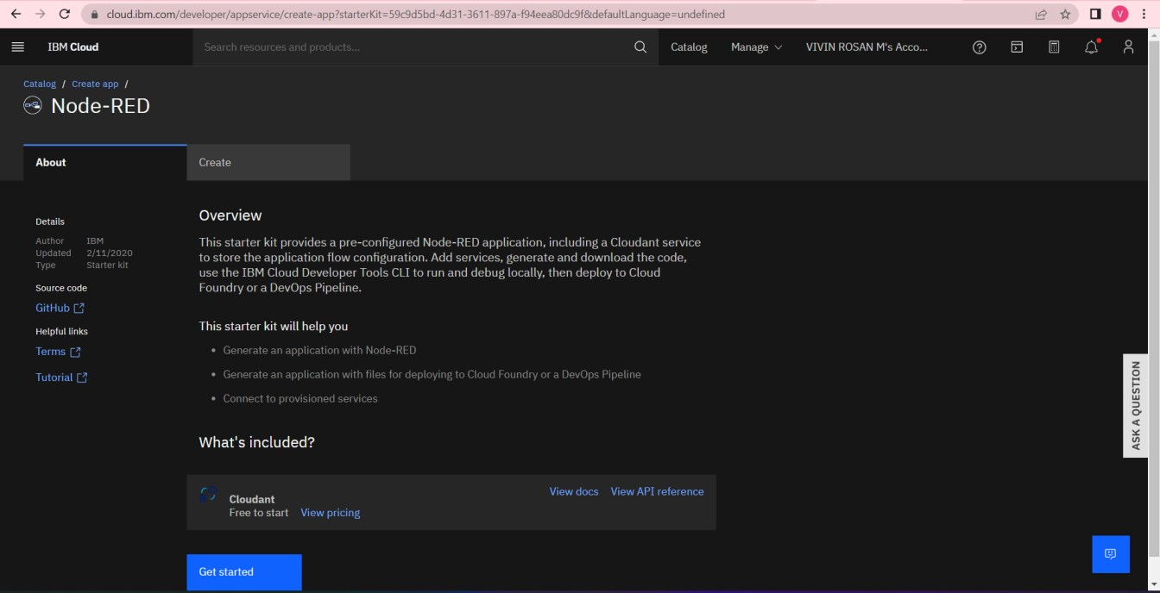

* Enteredprojectdetailsandclickedoncreate

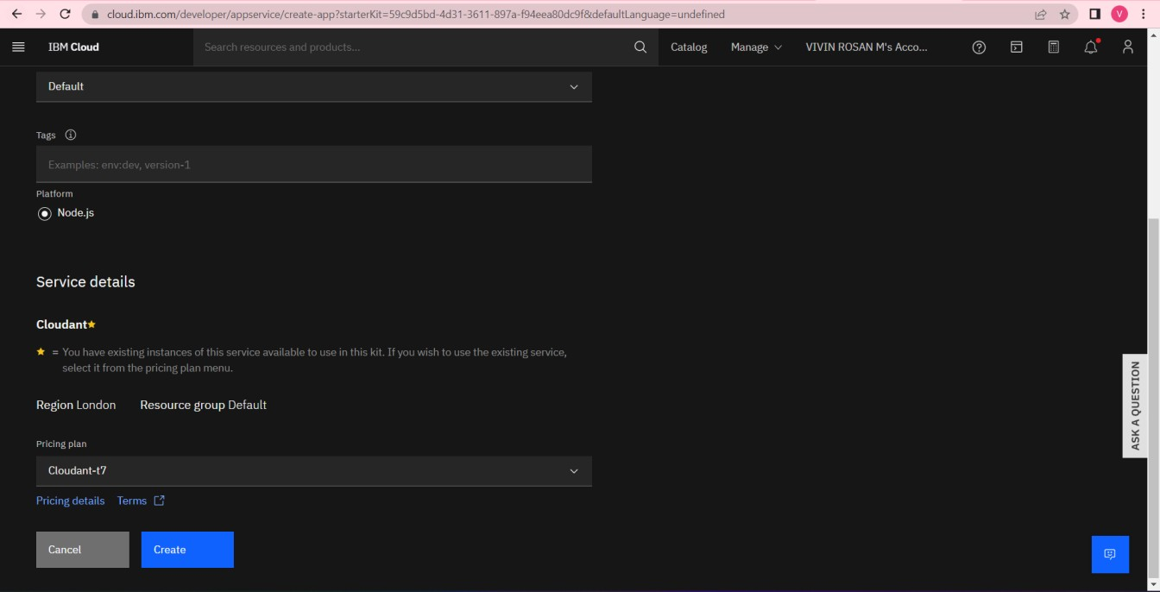

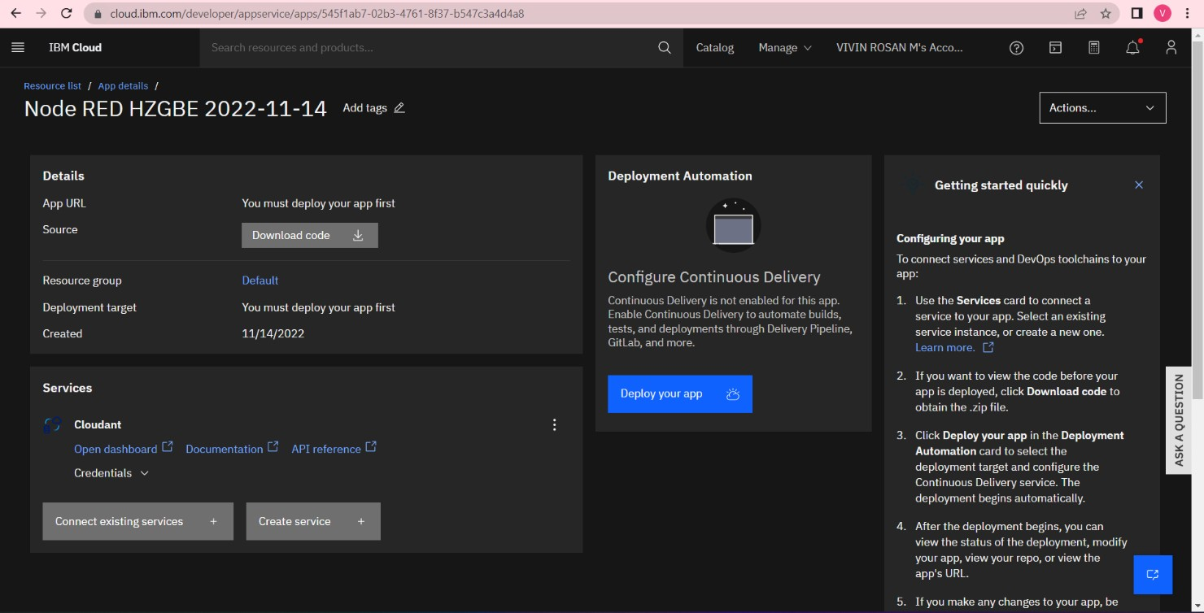

* Settinguptheenvironmentanddeployingtheapp

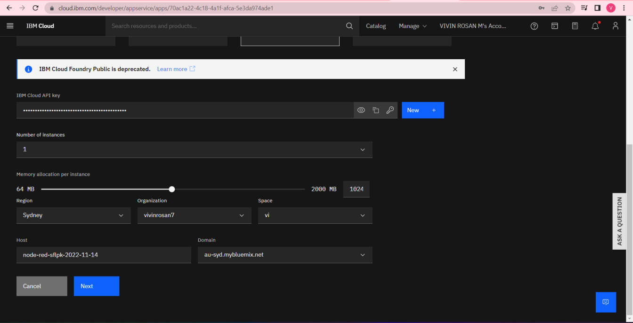

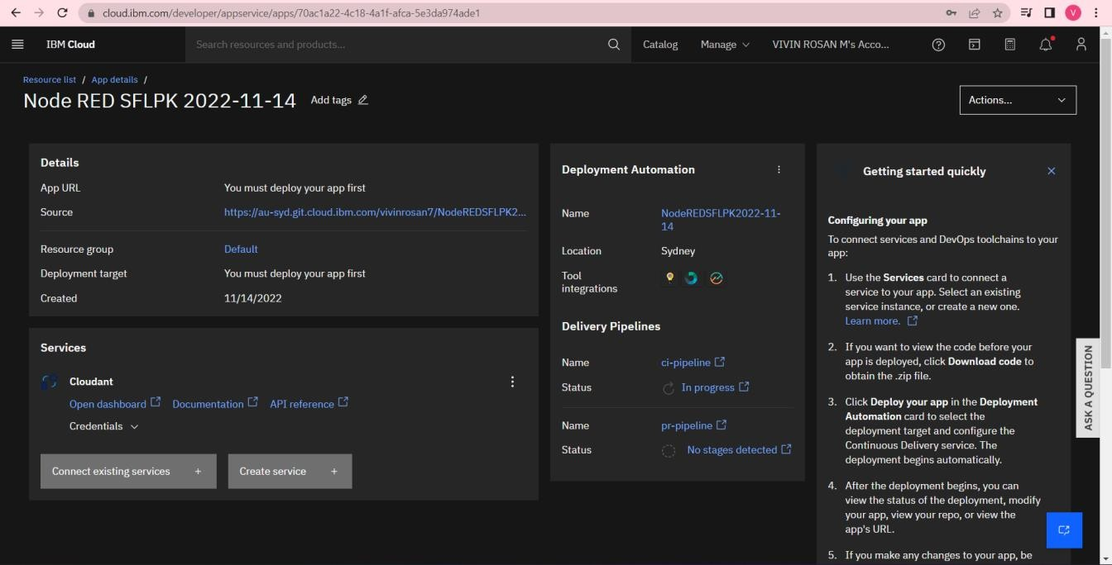

* Welcomedbytheinstanceeditor

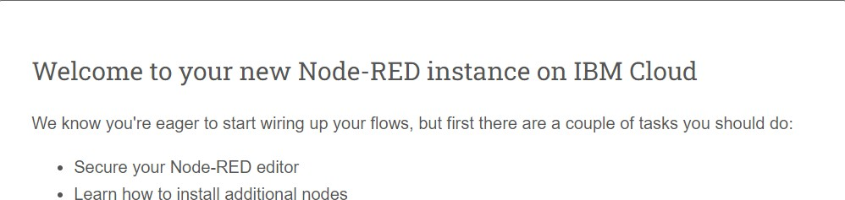

* Settingupcredentials

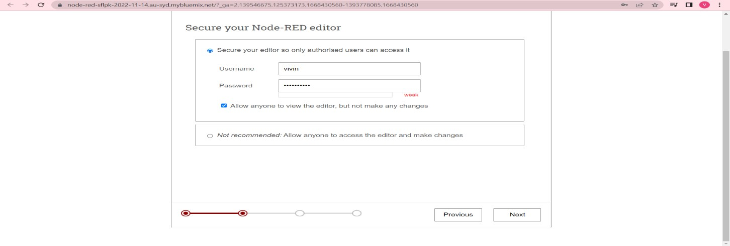

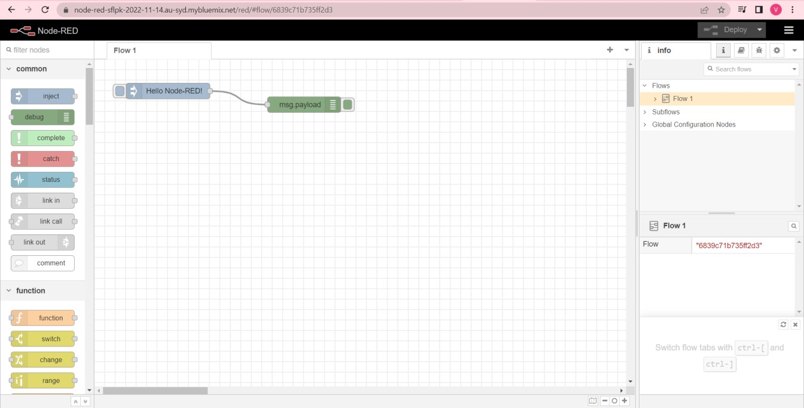

* Editingsomevaluesoftheproperties

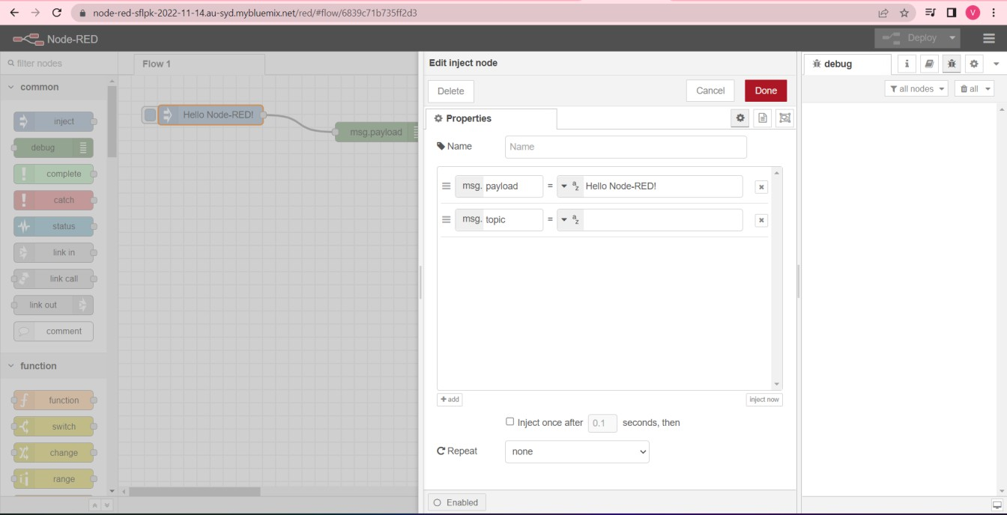

* Successfullydeployedtheapp

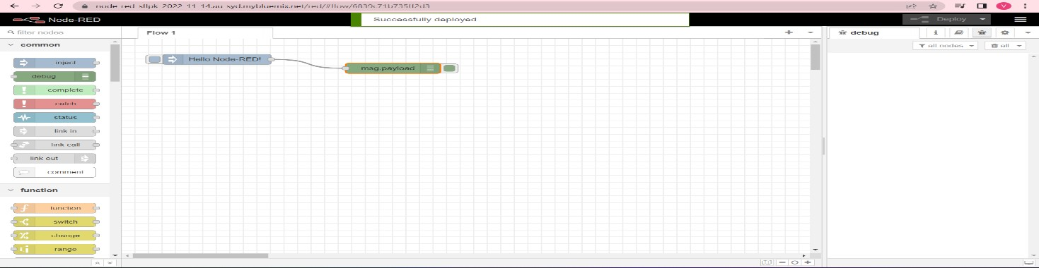

Result:SuccessfullycreatedaNodeREDserviceonIBMCloud